**PROJECT REPORT**

**1. INTRODUCTION**

**1.1 OVERVIEW**

Analysing Housing Prices in Metropolitan Areas of India experiences similar urbanisation challenges as other fast growing cities in [developing countries](https://en.wikipedia.org/wiki/Developing_countries): wide disparities in housing between the affluent, middle-income and low-income segments of the population.

**1.2 PURPOSE**

Property prices in India are expected to increase 7.5% on a pan-India basis this year, the fastest growth in five years, according to a Reuters poll of property analysts. Average house prices were forecast to rise 6% next year and in 2024. The poll of 13 property analysts were held during

**2. PROBLEM DEFINITION & DESIGN THINKING**

2.1 EMPATHY MAP

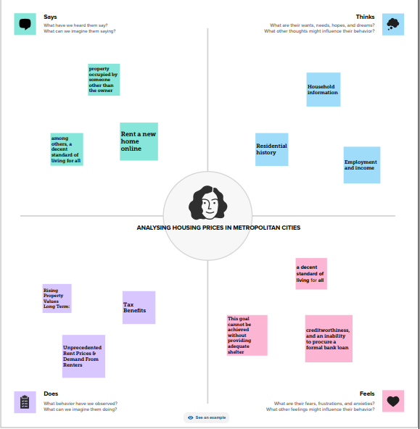

2.2 IDEATION AND BRAINSTORMING MAP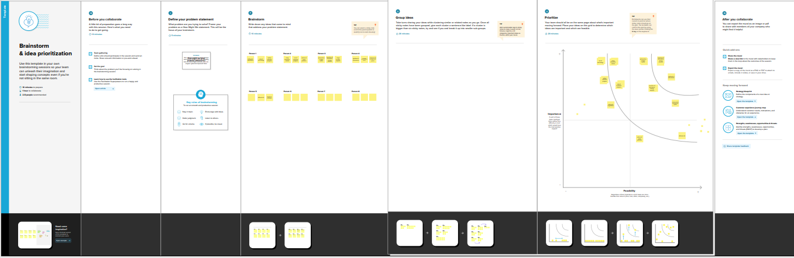

**3. RESULT**

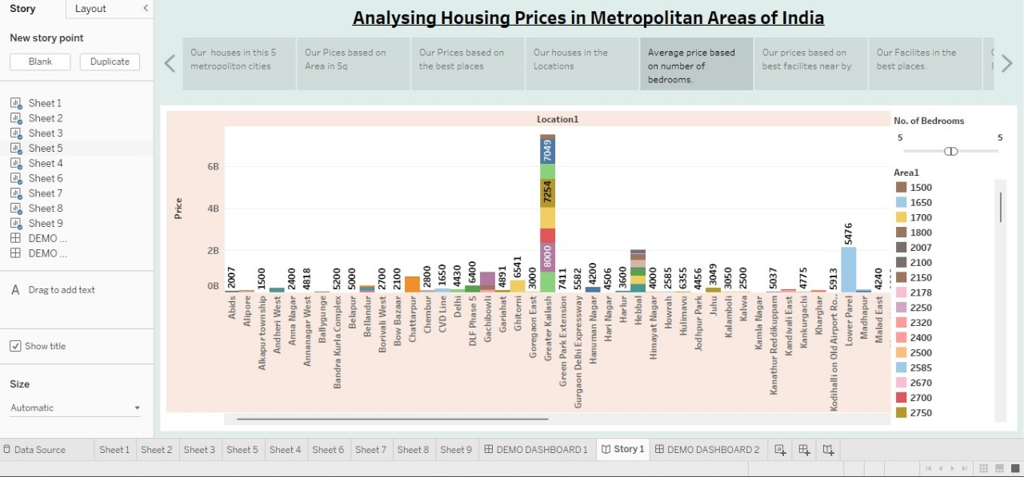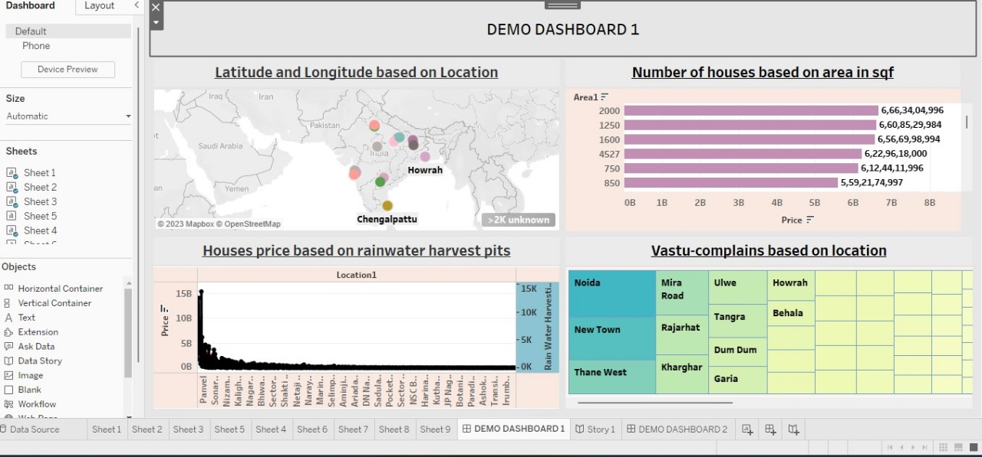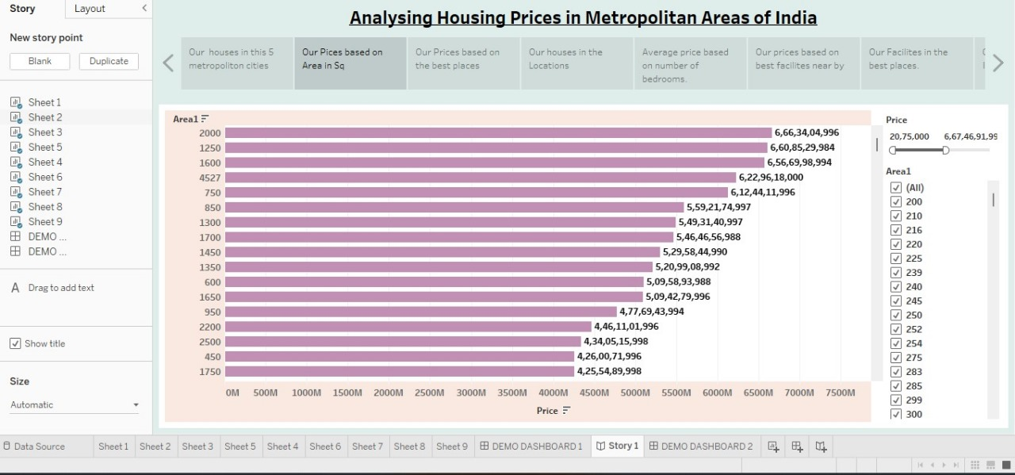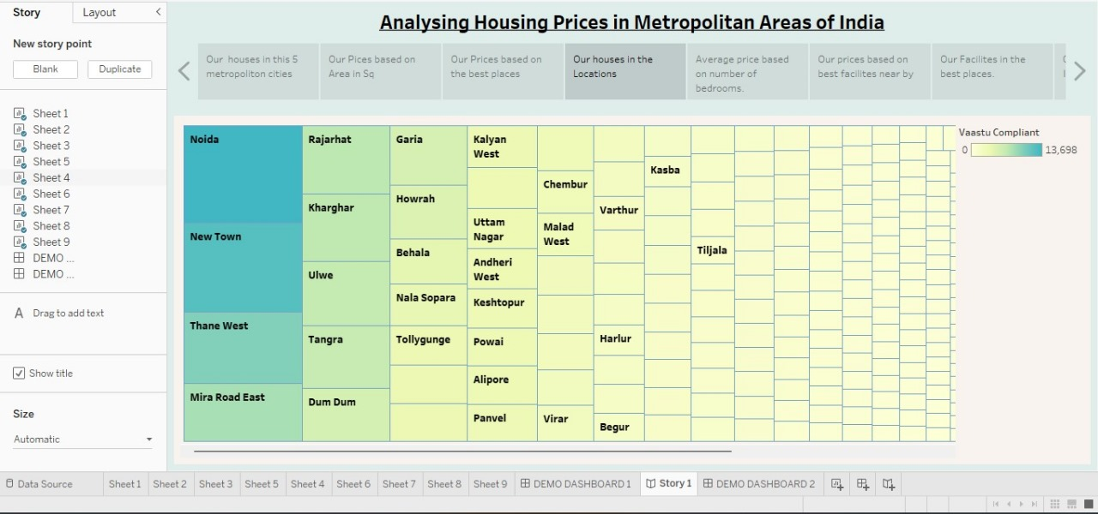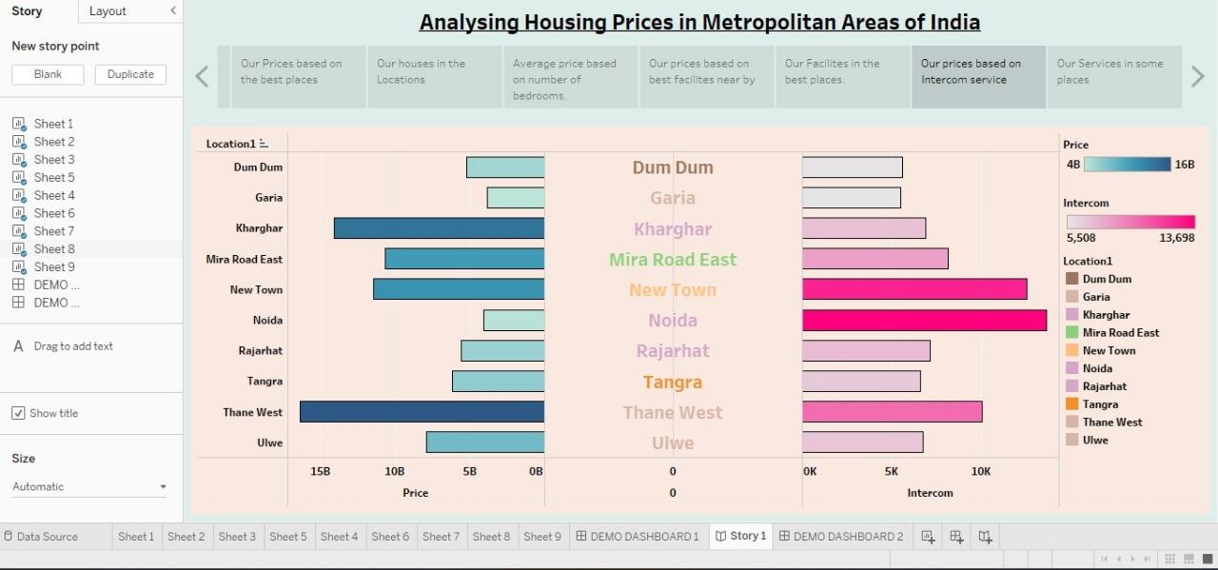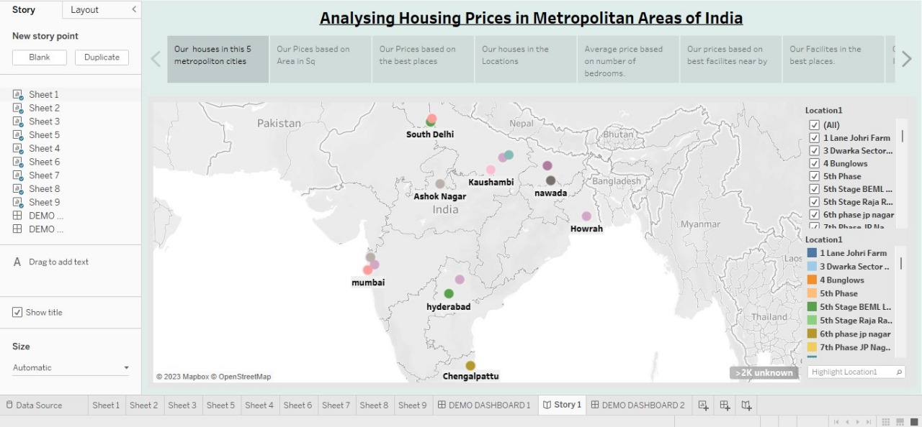

**3.2 STORY**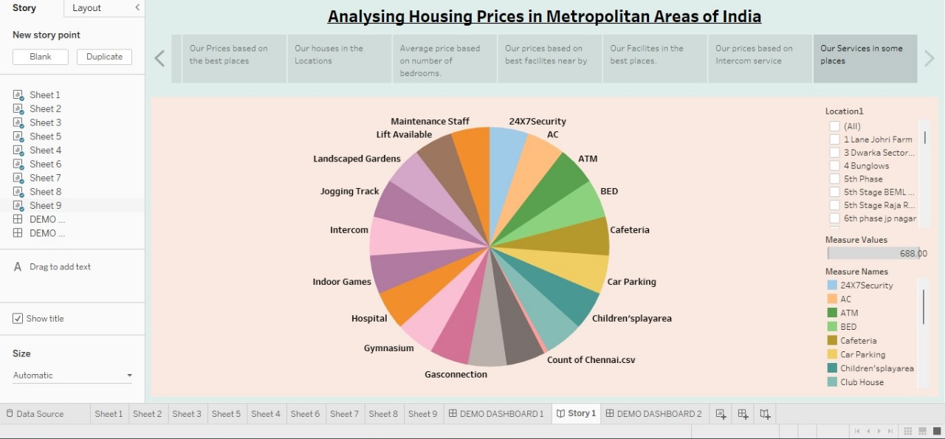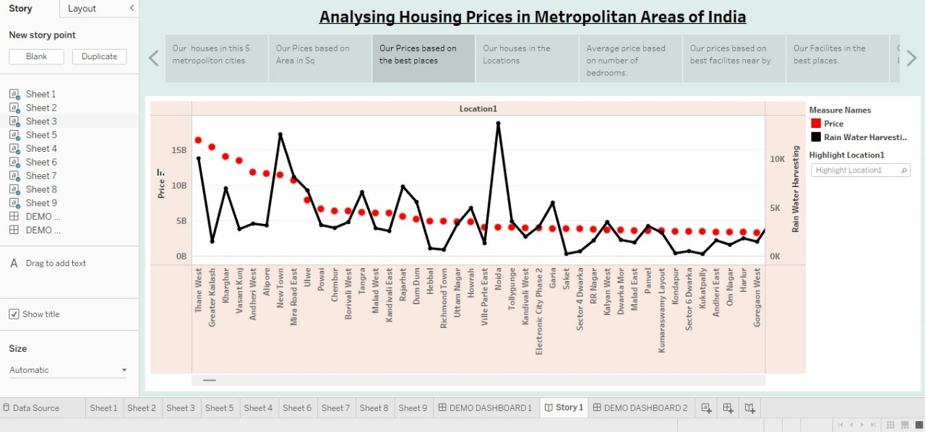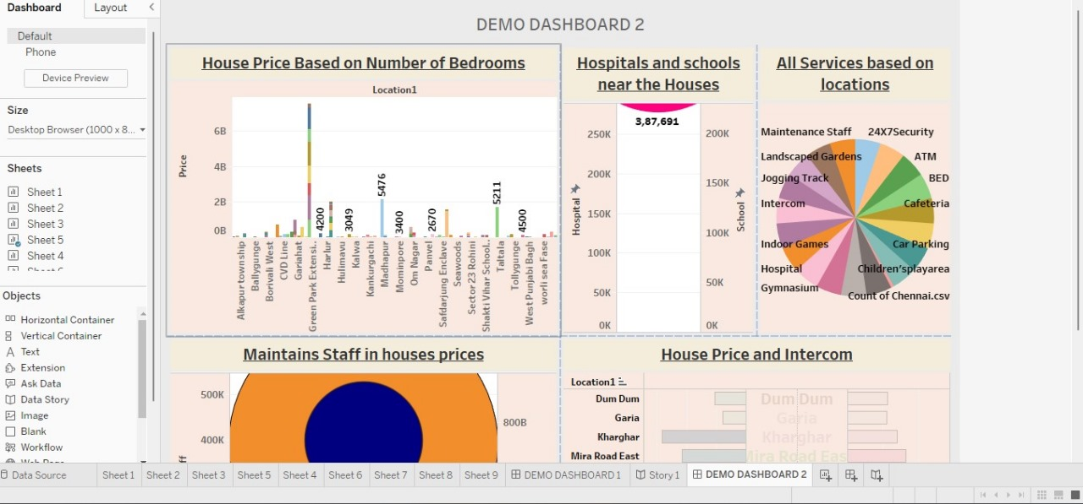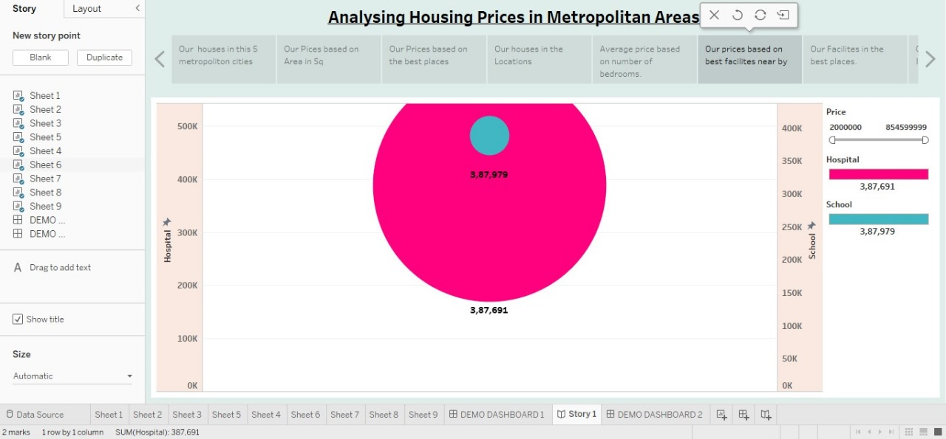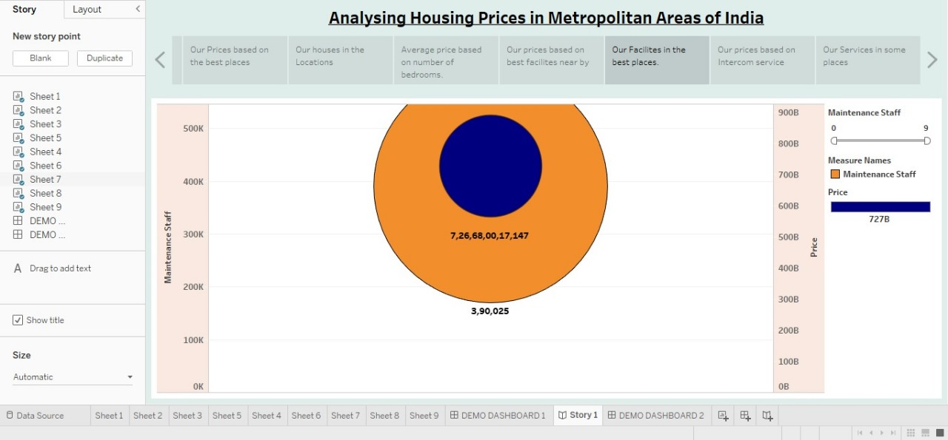

**4. ADVANTAGES AND DISADVANTAGES**

**ADVANTAGES**

Major cities always have a **higher** cost of **living** than the neighboring towns. Ordinary **living costs** like rent and utilities tend to be **higher** in major cities

The extensive **transportation** networks that cities offer are one of the additional benefits of living in a city. In addition to buses, taxis, and the metro

**Best** medical services **possible** ... Compared to the big city, rural communities lack the facilities and resources necessary to provide good medical treatment

**DISADVANTAGES**

Huge **entertainment** opportunities. You probably know your town very well

**HIGHER PREMIUMS INSURANCE**. In the city traffic and vehicles are increasing with the huge population which is why insurance premiums are very high in the cities

Without these, our cities are bland and uninteresting. Crowded sidewalks, crowded shops, **lack of parking** places in citie

We learn to be forgiving and understanding. It provides us with opportunities to help others. The advantages would be lots of open **space**